|  |
| --- |
|  |
| October 2014 – Roby Elementary School |
|  |

Special Area Newsletter

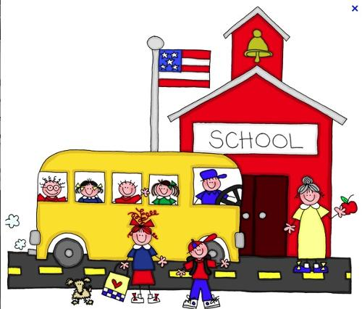

# Special Area Teachers

## Courtney Kimes, Art

Courtney.kimes@bullitt.kyschools.us

## Geneva Lyons, Counselor

Geneva.lyons@bullitt.kyschools.us

## Terri Jeffrey, Library

Terri.jeffrey@bullitt.kyschools.us

**Stacey Oliver, Music**

Stacey.Oliver@bullitt.kyschools.us

**Brittany Henon, PE**

Brittany.Henon@bullitt.kyschools.us

|  |
| --- |
|  |
| Important Announcement Backyard Book Fair and  Grandparent’s Lunch  October 20-24, 2014  Falloween  October 30, 2014  5:30-7:30 |

Art, Counselor, Library, Music and Physical Education

|  |
| --- |
|  |
| Spotlight on Art: The National Art Education Association states that art teaches students about the value of work, enhances verbal expression, and instills values. Read more at:  <http://www.arteducators.org/advocacy/why-art-education> |
|  |

## http://school.discoveryeducation.com/clipart/images/art-color.gifArt

[Courtney.kimes@bullitt.kyschools.us](mailto:Courtney.kimes@bullitt.kyschools.us)

Art students have been busy this month! We are learning all about the elements of art: Line, Shape, Color, Form, and Texture.

**Kindergarten** is using building blocks to learn about the difference between shape and form.

**1st Grade** just finished making texture crayon rubbings in the courtyard.

**2nd Grade** is using warm and cool colors to paint a landscape.

**3rd Grade** is making sculptures out of milk cartons and juice cups.

**4th Grade** is making Notans (cut paper designs) using complimentary colors.

**5th Grade** is writing artist statements that will be published on the Artsonia website.

** Artsonia is up and running! Go to artsonia.com to activate your free account and view the Roby Student Gallery.

** Parents, please send an old oversized shirt to be used as a painting smock if you want to protect your child’s clothing from paint. Thank you!

## C:\Users\glyons\AppData\Local\Microsoft\Windows\Temporary Internet Files\Content.IE5\CEKCPQPE\MC900282428[1].wmfCounselor’s Corner

[Geneva.lyons@bullitt.kyschools.us](mailto:Geneva.lyons@bullitt.kyschools.us)

This month we talked about Respect. The lesson focused on respecting oneself, appreciating differences, manners, and building positive relationships.

I offer small group guidance. If your family is dealing with grief, divorce, or other changes, let me know.

**@Your Library**

[Terri.jeffrey@bullitt.kyschools.us](mailto:Terri.jeffrey@bullitt.kyschools.us)

****We explored the concept of fiction and non-fiction text with our Kindergarten classes. We are now learning about the four seasons by reading two of the nominated Kentucky Bluegrass Award books. The library has all the nominated titles for grades K-2 and 3-5 available for check-out. Please encourage your students to read these outstanding titles so they can have a say in which book will win the 2015 prize as the best book for children as voted on by students in the State of Kentucky. Master Lists can be found at <http://kba.nku.edu/participate/master_lists.shtml>.

Grade 3 students learned about the difference between using the Internet and online databases in their research about weather disasters.

Participating students have until October 3 to turn in their READO cards to be entered into a prize drawing. They needed to complete a least one READO (think BINGO) to be entered into the drawing.

Over 1,975 books were checked out in September! Visit the library blog at <http://blogs.bullittschools.org/reslibrary/>.

**Music**

[Stacey.Oliver@bullitt.kyschools.us](mailto:Stacey.Oliver@bullitt.kyschools.us)

PAC auditions were successful.  Congratulations to the students who auditioned and were accepted.

2nd-5th grade are learning to read music in the treble clef.  4th grade received their recorders and are beginning to learn the basics of playing.  (Please make sure students have their recorder for music class).  Kindergarten and first grade are exploring their voices.

Upcoming Performances: PAC at Fall Festival!  Details TBA.

**Physical Education**

[Brittany.Henon@bullitt.kyschools.us](mailto:Brittany.Henon@bullitt.kyschools.us)

[](http://www.google.com/url?sa=i&rct=j&q=&esrc=s&frm=1&source=images&cd=&cad=rja&docid=zVNfgcEQGJ5KXM&tbnid=Zyx8LRr6N2o3kM:&ved=0CAUQjRw&url=http://www.epd86.org/CJHS/StaffPages.htm&ei=fo4XUpfXL47-9gS3joCYCg&bvm=bv.51156542,d.b2I&psig=AFQjCNFg_LV8VKb-WegEQhWGgy9J32fMFg&ust=1377361895467102)During the month of September students in grades 2-5 completed the Presidential Challenge pre-tests. Students in Kindergarten and 1st grade practiced some of the same stations! These tests included: sit-ups, sprinting, stretching, chin- ups, and long distance running. Each child will be given a sheet with all of their results and their goals for the post-test (based on age). Students will complete the post-tests at the end of the year. Their goal is to keep practicing so that they can improve. During the month of October we will focus on soccer and other small ball skills. Nutrition and fitness will be embedded in the lessons.

Please remember to check the lost and found! Several students have left/lost things in PE class!

**Please remember that it is very important that all students wear tennis shoes to school every day!** If your child is unable to participate in P.E. for a particular reason, please be sure to send a note with them! P.E. grades are based on participation, cooperation, sportsmanship skills, and behavior in class. There will also be written assignments that the students will be graded on throughout the year. Students are not graded on their “athletic ability” but they are graded on their willingness to try all activities!