|  |
| --- |
|  |
| September 2014 – Roby Elementary School |
|  |

Special Area Newsletter

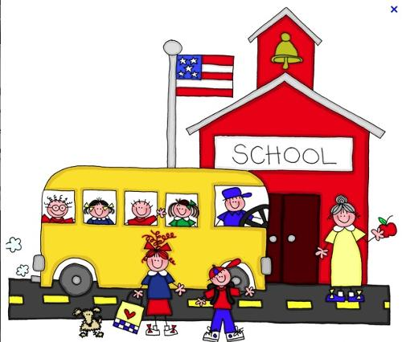

# Special Area Teachers

## Courtney Kimes, Art

Courtney.kimes@bullitt.kyschools.us

## Geneva Lyons, Counselor

Geneva.lyons@bullitt.kyschools.us

## Terri Jeffrey, Library

Terri.jeffrey@bullitt.kyschools.us

**Stacey Oliver, Music**

Stacey.Oliver@bullitt.kyschools.us

**Brittany Henon, PE**

Brittany.Henon@bullitt.kyschools.us

|  |
| --- |
|  |
| Important Announcement Backyard Book Fair and  Grandparent’s Lunch  October 20-24, 2014 |

Art, Counselor, Library, Music and Physical Education

|  |
| --- |
|  |
| Special Area teachers welcome you to a new school year! We are excited to be a part of your student’s educational experience. A warm welcome to the new additions to our Special Area team: Ms. Courtney Kimes, Art Teacher, and Ms. Stacey Oliver, Music Teacher. |
|  |

## Art

[Courtney.kimes@bullitt.kyschools.us](mailto:Courtney.kimes@bullitt.kyschools.us)

Art class is off to a great start!   Students are using the art elements of Line, Shape, and Color to create some amazing works of art!

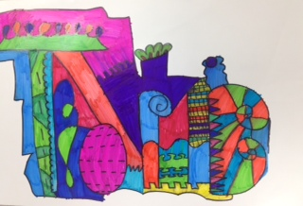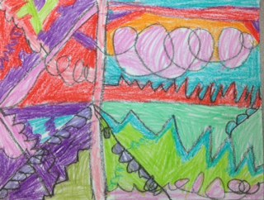

I am excited to announce that I have signed up for an account on ARTSONIA, which is a website that lets me keep student portfolios in digital format.  This will allow you to see your child’s growth from Kindergarten all the way through 5th grade!  You will also be able to purchase a variety of gifts that feature your child’s art.  Gifts include: t-shirts, tote bags, mugs, mouse pads, phone cases, and much more!  15% of all purchases go to Roby Art!  I will be sending more information home in the coming weeks.

## C:\Users\glyons\AppData\Local\Microsoft\Windows\Temporary Internet Files\Content.IE5\CEKCPQPE\MC900282428[1].wmfCounselor’s Corner

[Geneva.lyons@bullitt.kyschools.us](mailto:Geneva.lyons@bullitt.kyschools.us)

Within in the next couple of weeks, I will be sending home a counseling brochure that outlines the services I offer to students and families. One of the services I offer is Classroom Guidance lessons. These lessons focus on positive character traits. Students receive these monthly lessons in Topsy Turvy.

This month we talked about our procedure for name calling, teasing, and taunting. Please ask your student(s) to demonstrate STOP, WALK, and TALK.



**@Your Library**

[Terri.jeffrey@bullitt.kyschools.us](mailto:Terri.jeffrey@bullitt.kyschools.us)

Welcome back to your library! We spent the month of August reviewing book care and behavior expectations. Most grade levels have experienced their first check-outs of the year.

We are excited to support the new science standards with a wide array of new science books purchased over the summer. We will have those titles displayed in September.

We had a great time celebrating our summer reading successes with an ice cream party on August 21. Students that completed their summer reading goals are: **Grade 1**: Isaac Lay, Ava Newton, Emma Holt, Kaitlyn Miller; **Grade 2**: Tamira Dolic, Daniel Loudin-Magnuson, Grace Clark, Taylor Franke; **Grade 3**: Jake Newton, Beau Hornak, Laci Poynter; **Grade 4**: Alexis Bailey, Ian Cromer, Grace Murdock; **Grade 5**: Kyle Franke, Alexis Miller.

Visit the library blog at <http://blogs.bullittschools.org/reslibrary/>.

**Music**

[Stacey.Oliver@bullitt.kyschools.us](mailto:Stacey.Oliver@bullitt.kyschools.us)

We are having a great time in music class! Your students are working hard and becoming more musical every day! 4th and 5th have learned how to play "Turn the Glasses Over" on the Orff instruments. 2nd, 3rd and 1st grade are working hard learning how to count rhythms and play them on various percussion instruments.  Kindergarten is working on keeping a steady beat and moving to music.

Reminder that Recorder Permission Slips/Money and PAC forms are due August 29.  PAC will start on September 2.

Please check my website for upcoming events/news: oliversmusicroom.weebly.com

I look forward to a great year with Roby students!

**Physical Education**

[Brittany.Henon@bullitt.kyschools.us](mailto:Brittany.Henon@bullitt.kyschools.us)

Welcome back! My name is Mrs. Henon and this is my 9th year of teaching at Roby Elementary. In the month of August students learned a variety of first-aid and safety procedures. We also went over some good hygiene habits. In September we will be doing some circuit training and the students will be completing the Presidential Challenge pre-test. This is a fitness test and it is meant to be done at the beginning of the year and again at the end of the year, in order to show growth.

Please remember that it is very important that all students wear tennis shoes to school every day! If your child in unable to participate in P.E. for a particular reason, please be sure to send a note with them! P.E. grades are based on participation and behavior in class. There will also be written assignments that the students will be graded on throughout the year. Students are not graded on their “athletic ability," but they are graded on their willingness to try all activities!

I am looking forward to great year!

